HashCode Method :->

HashCode is native method present in Object class.

what is native ??

public native void createNativeMethod();

if u use the native keyword then we dont need to add the implementation body to the method ....

native means in native language implementation to this method has already been there. we need to just use this method in java....

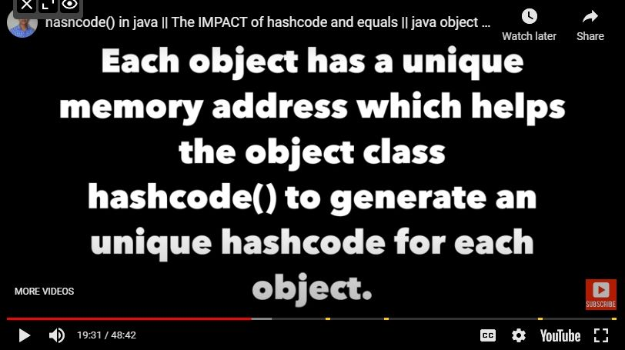

**above image means that hashcode is not the address of the object** ...but it is being used when hascode will get calculated via JVM...

1) yes, we can override the hashcode method, but remember that hashcode method should return the unique value...

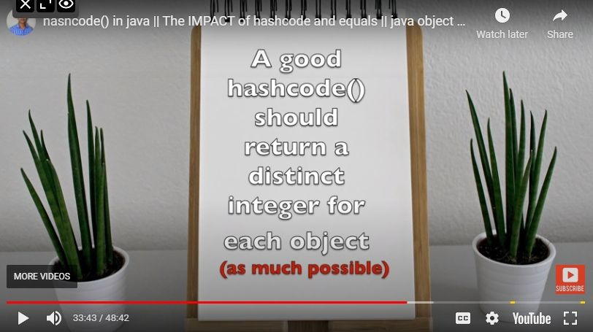

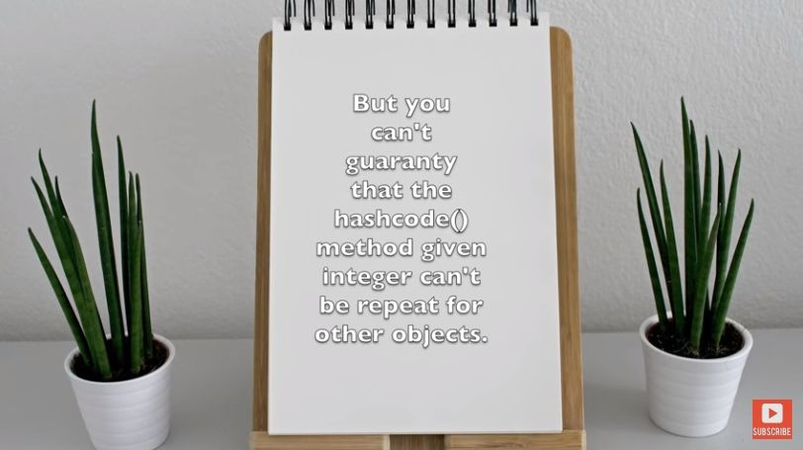





Equals Method :->

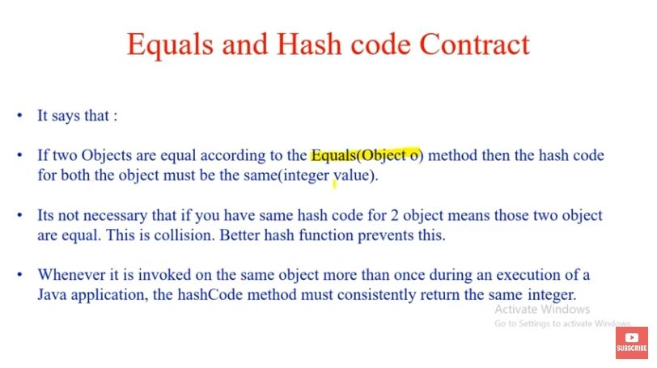

one catch is here -->>

consider if h1 ref and h2 ref are the same type but different object and haveing the same content ..

then , h1 == h2 ---> false

but h.age == h2.age ---> true

and remeber

h1.equals(h2) will also give false if u wont override the equals method in your class...